DIGITAL LOGIC DESIGN PRACTICAL
AIM
Implement XOR, Mux (2-way, 4-way), and DMux chips in HDL.
XOR chip
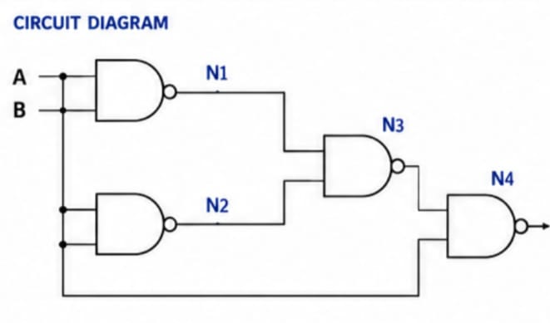
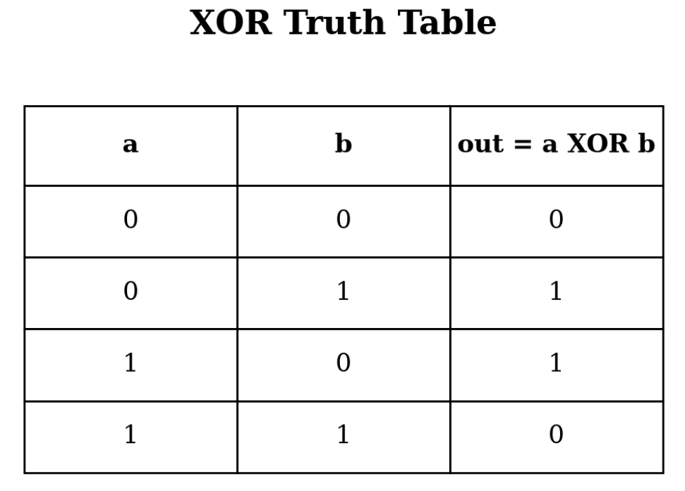

BOOLEAN EXPRESSION

out = a'b + ab'

MUX chip(2-way)
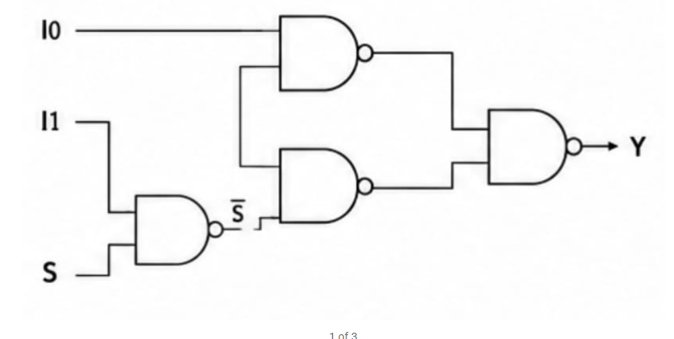
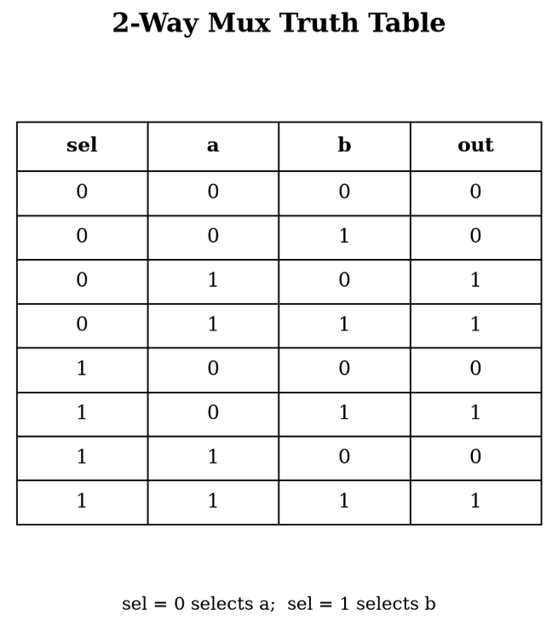

BOOLEAN EXPRESSION

out = a·sel' + b·sel

DMux chip
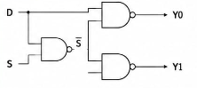
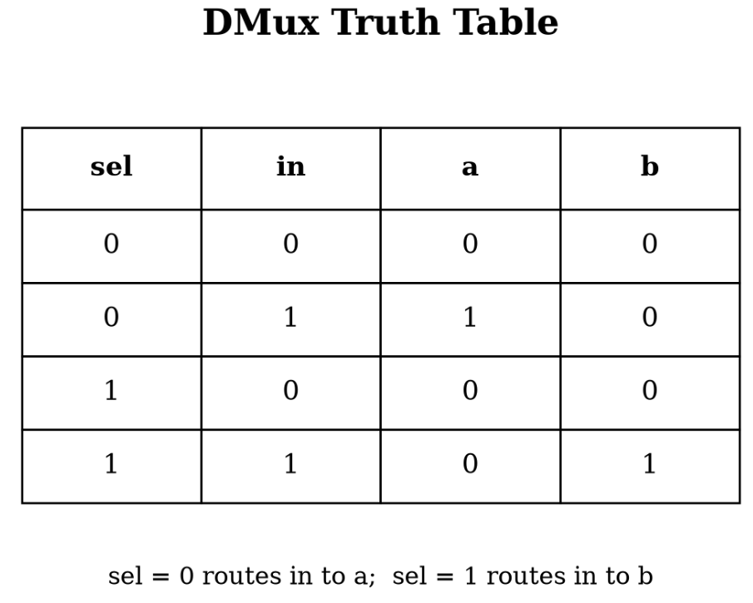
BOOLEAN EXPRESSION

a = in·sel'
b = in·sel
HDL CODE
XOR chip
CHIP Xor {
IN a, b;
OUT out;
PARTS:
Nand(a=a, b=a, out=x);
Nand(a=b, b=b, out=y);
Nand(a=a, b=y, out=z);
Nand(a=b, b=x, out=z1);
Nand(a=z, b=z1, out=out);
}

Mux chip (2-Way)
CHIP Mux {
IN a, b, sel;
OUT out;
PARTS:
Not(in=s, out=n);
And(I0= I0, I1=nsel, out=x);
And(I0=b, I1=sel, out=y);
Or(I0=x, L1=y, out=out);
}
DMux chip
CHIP DMux {
IN in, sel;
OUT a, b;
PARTS:
Not(in=sel, out=nsel);
And(a=in, b=nsel, out=a);
And(a=in, b=sel, out=b);
}
SIMULATION OUTPUT
XOR chip
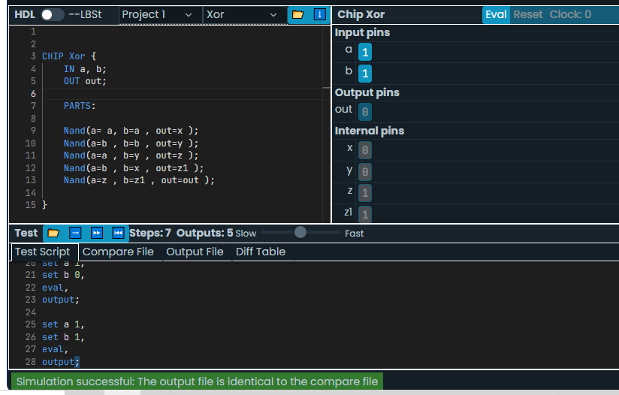

Mux chip (2-Way)
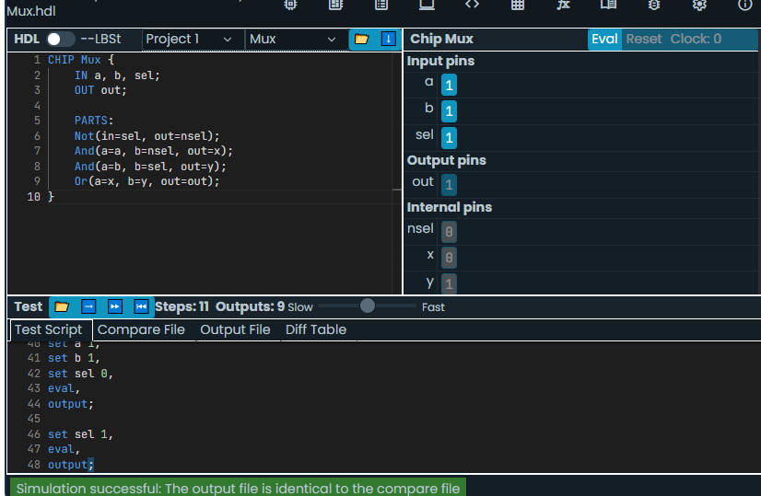

DMux chip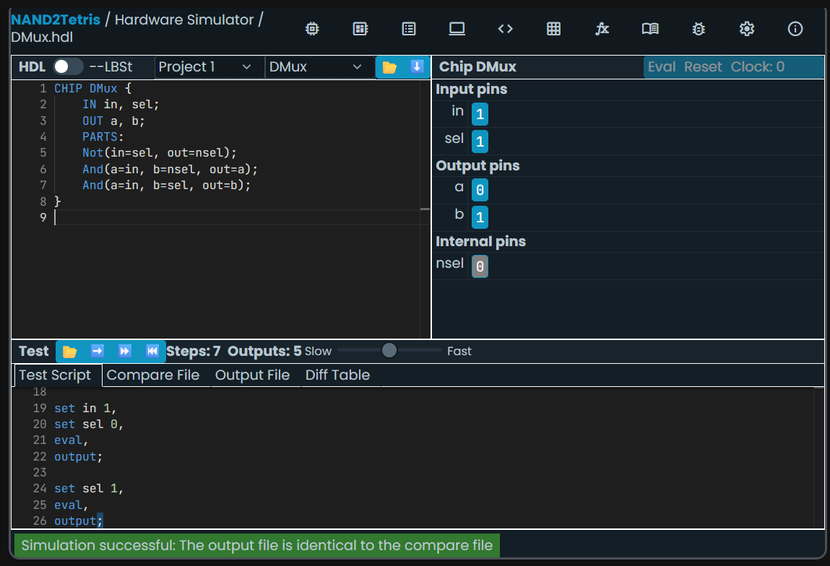

RESULT
The XOR, 2-Way Mux, Mux4Way16, and DMux chips were implemented successfully using HDL. The outputs can be verified using the Nand2Tetris Hardware Simulator and compared with the expected truth tables and test scripts.

